The magnitude of income shock exposure is **1.33** for the following plots.

1. The impulse responses of the income process $Y_{t+j}^{1}$

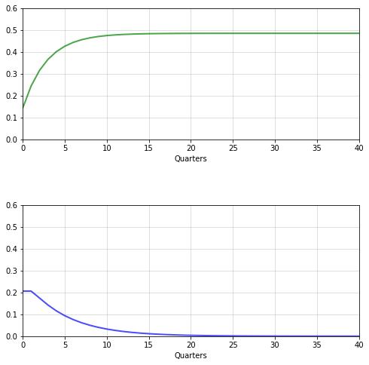

1. The impulse responses of the consumption process $C_{t+j}^{1}{+Y}_{t+j}^{1}$

(permanent shock = .482, transitory shock = .00383)

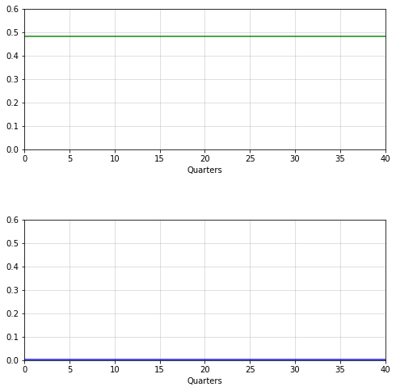

1. The impulse responses of the consumption/income ratio $C_{t+j}^{1}$

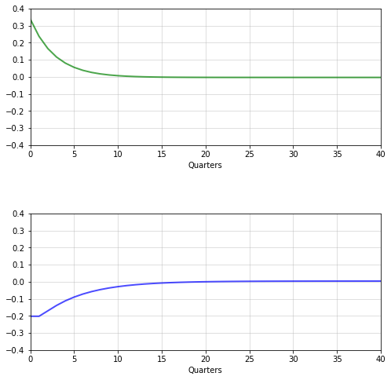

1. The discounted cumulative sum of impulse responses for $C_{t+j}^{1}$

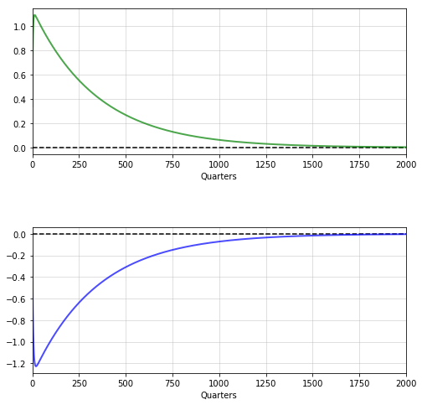

1. Subjective discount rates $δ$ versus robustness $\frac{1}{ξ}$. The uncertainty price vector for the two shocks is:

$$-\frac{1}{ξ}\left(F_{c}+F_{y}\right)=-\frac{1}{ξ}\left[\begin{aligned}.482 \\ .00383\end{aligned}\right]$$

